IPv6

Transition

Introduction

• IPv4 and IPv6 are not interoperable.

• Until IPv6 completely supplants IPv4, which is not likely to happen in the foreseeable future, a number of so-called transition mechanisms are needed :

▪ To enable IPv6-only hosts to reach IPv4 services.

▪ To allow isolated IPv6 hosts and networks to reach the IPv6 Internet over the IPv4 infrastructure.

Node Types

• IPv4-only node

▪ Implements only IPv4 & is assigned IPv4 addresses ▪ Doesn’t support IPv6

• IPv6-only node

▪ Implements only IPv6 & is assigned only IPv6 addresses.

▪ Able to communicate with IPv6 only node & IPv6 enabled applications.

• IPv6/IPv4 node

▪ Implements both IPv4 & IPv6 & is assigned both IPv4 & IPv6 addresses.

IPv6 Transition Techniques

**A wide range of techniques have been identified & implemented, basically falling into three categories:**

**(1) Dual- Stack :**

**It allows IPv4 & IPv6 to coexist in the same**

**device & network**

**(2) Tunneling :**

**It allows IPv6 host to communicate over IPv4 infrastructure.**

**(3) Translation :**

**It allows IPv6 only devices to communicate**

**with IPv4 only devices**

**IPv6**

**Transition Mechanism**

⮚**Transition Options:** ▪ **Dual Stack**

▪ **IPv6-IPv4 Tunnel**

**APPLICATION**

**TCP/UDP**

***IPv4 IPv6***

**DRIVER**

**IPv4 IPv6** IPv6 IPv4

Network **Tunnel**

▪ **Translation (IPv6- only to IPv4- only)**

IPv6

Network **~~Translator~~**

IPv6

Network

IPv4

Network

**IPv6**

**Dual Stack**

• Require network devices such as routers and end system running both IPv4 and IPv6 protocol stacks.

If both the end stations support IPv6, they can communicate using IPv6; otherwise they will communicate using IPv4.

This will allow both IPv4 and IPv6 to coexist and gradual transition from IPv4 to IPv6 can happen.

Dual Stack Hosts and Network

**IPv4**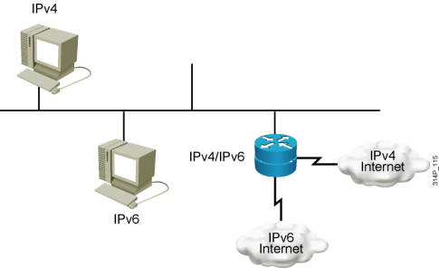

**IPv6**

Dual stack is an integration method in which a node has implementation and connectivity to both an IPv4 and IPv6 network.

Dual Stack Hosts and Network

**IPv4: 192.168.99.1** 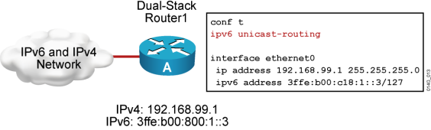

**IPv6: 3ffe:b00:c18:1::3**

When both IPv4 and IPv6 are configured on an interface, the interface is considered dual-stacked.

IPv4-IPv6 Dual Stack Operation

**www.a.com=*? 3ffe:b00::1**

**IPv4**

**Network**

**DNS Server**

**10.1.1.1**

**Web Server**

**www.a.com**

**3ffe:b00::1**

**IPv6**

**Network**

Tunneling IP6 via IP4

• Tunneling encapsulates IPv6 traffic within IPv4 packets.

• Allows isolated IPv6 end system and routers to communicate without the need to upgrade the IPv4 infrastructure that exists between them.

IPv6 over IPv4 Tunnels

**IPv6 header IPv6 data IPv6**

**Dual-stack Router**

**IPv4 Network**

**IPv6 header IPv6 data**

**Dual-stack**

**Router**

**NetworkIPv6**

**Network**

**Tunnel: IPv6 in IPv4 Packet**

**IPv6 host IPv6 hostIPv4 header IPv6 header IPv6 data**

**Tunneling IP6 via IP4** IPv6 Packet

IPv6 Header Extension Headers 

IPv6 Header Extension

Upper Layer Protocol Data Unit 

Upper Layer Protocol

Data Unit IPv4 Header Headers

IPv4 Packet

Tunneling IP6 via IP4

**Tunnel**

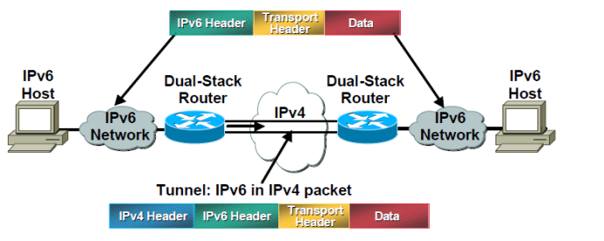

**Packet Delivery over the tunnel**

• **IPv6 node A sends packet to IPv6 node B**

–Routed internally to router A

• **Router A sees destination network B is reachable over tunnel interface**

–Encapsulates IPv6 packet in IPv4 packet(s)

–Sends resulting IPv4 packet(s) to router **B**

–Delivered over existing IPv4 Internet infrastructure

• **Router B decapsulates IPv6 packet from payload of received IPv4 packet**

–Packet routed internally in network B to node B

–Node B receives the IPv6 packet

IPv6 Tunneling

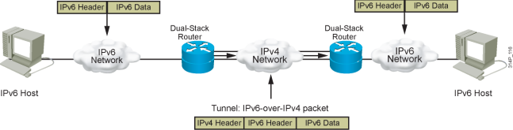**IPv6 IPv4 IPv6 IPv6**

Tunneling is an integration method in which an IPv6 packet is encapsulated within another protocol, such as IPv4. This method of encapsulation is IPv4.

▪ Includes a 20-byte IPv4 header with no options and an IPv6 header and payload ▪ Requires dual-stack routers

Tunneling Configurations

• Router-to-Router

• Host-to-Router and Router-to-Host • Host-to-Host

Router-to-Router Tunneling

IPv4 or IPv6

Infrastructure

IPv6

IPv4 Infrastructure

~~IPv6 over IPv4 Tunnel~~

IPv4 or IPv6

Infrastructure

IPv6

Node

IPv6/IPv4 Router IPv6/IPv4 Router

Node

In the router-to-router tunneling configuration, two IPv6/IPv4 routers connect two IPv6-enabled infrastructures over an IPv4- only infrastructure

Host-to-Router and Router-to-Host Tunneling

IPv4 Infrastructure

IPv4 or IPv6

Node A Node B Infrastructure

~~IPv6 over IPv4 Tunnel~~

IPv6/IPv4 IPv6 IPv6/IPv4 Router

In the host-to-router tunneling configuration, an IPv6/IPv4 host that resides within an

IPv4-only infrastructure uses an IPv6-over-IPv4 tunnel to reach an IPv6/IPv4 router.

Host-to-Host Tunneling IPv4 Infrastructure

~~IPv6 over IPv4 Tunnel~~

IPv6/IPv4 Node

IPv6/IPv4 Node

In the host-to-host tunneling configuration, an IPv6/IPv4 node that resides within an IPv4 only infrastructure uses an IPv6-over-IPv4 tunnel to reach another IPv6/IPv4 node that resides within the same IPv4-only infrastructure.

**Tunneling IP6 via IP4**

**Two Types of Tunneling** ▪ **Configured**

▪ **Automatic**

**Tunneling IP6 via IP4**

▪ Configured

▪ Require manual configuration at both ends

▪ Very easy to setup & configure

▪ Good from a management prospective

▪ Manual tunnel do not scale well as it requires separate tunnel configuration for each isolated IPv6 network destination

**Tunneling IP6 via IP4**

**Configured**

**A configured tunnels require manual configuration of the local & remote tunnel end points**

**Dual stack end points**

**Both IPv4 & IPv6 addresses configured at each end**

Tunneling IP6 via IP4

• Automatic Tunnel

❑An automatic tunnel is a tunnel is a tunnel that does not require manual configuration. Tunnel end points for automatic tunnel are determined by routing infrastructure (e.g. use of routes, tunnel interfaces, next hop address destination IPv6 addresses).

❑Tunnels created on demand without manual intervention

**IPv6-IPv4 Translation**

****This allows communication between IPv4 only and IPv6 only end stations.



The job of the translator is to translate IPv6 packets into IPv4 packets by doing address and port translation and vice versa.

**IPv6-IPv4 Translation**

****This allows communication between IPv4 only and IPv6 only end stations.

Assigned pool

Ford

ABCD:BEEF::2228:7001

**1. Packet 1**

**Source: ABCD:BEEF::2228:7001**

120.10.40/24Marvin 120.140.160.101

**2. Packet 2**

**Source: 120.10.40.10**

**Port 3056**

**Dest: Prefix :: 120.140.160.101 Port 23**

**4. Packet 4**

**Source Prefix :: 120.140.160.101 Port 23**

**Dest: ABCD:BEEF::2228:7001 Port 3056**

Translation

**Port 1025**

**Dest: Prefix :: 120.140.160.101 Port 23**

**3. Packet 3**

**Source: 120.10.40.10 Port 23**

**Dest: Prefix :: 120.140.160.101 Port 1025**

****The job of the translator is to translate IPv6 packets into IPv4 packets by doing address and port translation and vice versa.

Naming Services

• DNS must be included in transition strategy

• Resolving Names:

– IPv4 specifies “A” records

– IPv6 specifies “AAAA” records

• Applications should be aware of both records Pace University 26

Naming Services

Querying DNS server

Host A

IPv4 Only Network

Need an “A” record for www.yahoo.com

1 1

Need an “AAAA” record for

www.yahoo.com

Host B

IPv6 Only Network

2 2

Query response

216.109.117.206

Need all records for

1

www.yahoo.com

Host C

DNS server

Query response

2001:dc80:e100:164b::2

2

Query response

A= 216.109.117.206

Dual Stack Network

AAAA= 2001:dc80:e100:164b::2

Pace University 27

**IPv6**

**Conclusion**

• There are many IPv6 transition techniques available – No single ‘best’ solution

– Transition plan is likely to be site-specific

• Recommended best practice :Dual-stack deployment – Natural path via procurement cycles.

– Allows experience in IPv6 operation to be gained early.

Thanks